**Main Creator: Eva Zhang**

**Contributors: Rachel Rock, Nancy Padilla-Coreano**

**ANNOTATION FOR ALPHATRACKER**

**Lead time and constraints:**

* Requires installation of Anaconda-2.2.0-Windows-x86_64.exe (64-bit processor) or Anaconda-2.2.0-Windows-x86.exe
* Requires frames (can generate using Jupyter notebook)

**Time needed:** Highly variable depending on video quality, accuracy, and number of features labelled. Allow a minimum of one hour per 100 frames.

**NECESSARY MATERIALS/CHEMICALS**

* **Computer**

1. Move the frames that you wish to annotate from the folder where they are located in ./The Annotation Tool/json/im.

2. Click ​clickme.bat​. This will create a new json file named ​multi_person.json ​in ​/json​. Move the ​multi_person.json​ file to ​/json/im.

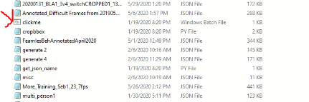

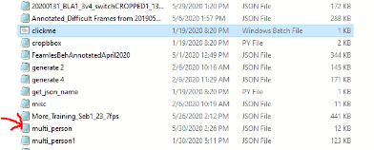

3. Rename the multi_person.json folder so that its name matches the name of the folder from which you took the images to annotate.

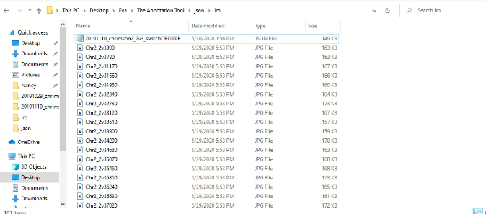

4. Go back to .​/tool​ and click ​start.bat​.

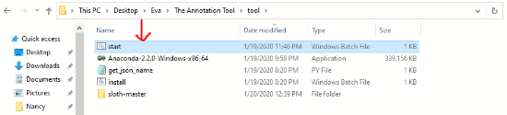

5. Choose File -> Open to open the ​multi_person.json ​file. All the images will be loaded.

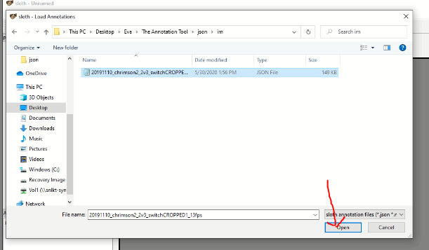

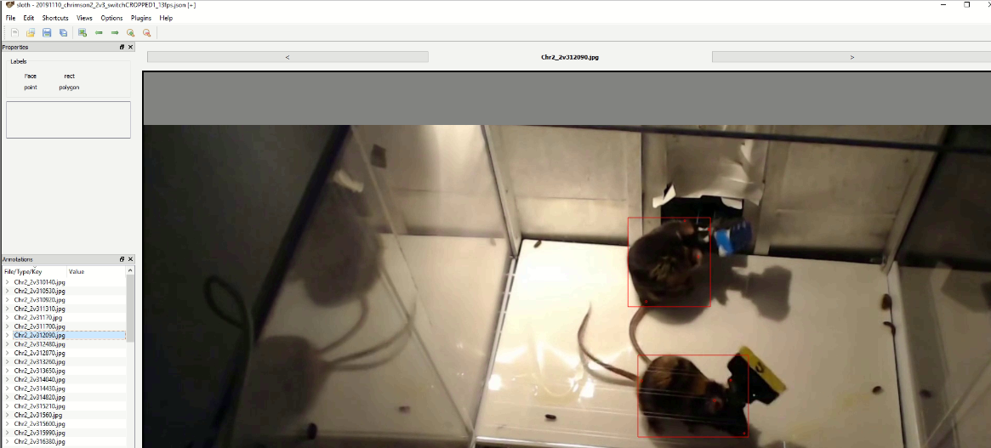

5. All the images are listed on the bottom left. Labeling options are on the top left. First choose a label option (e.g., Face, which generates a red bounding box) and then select the area of interest on the image shown on the right. The coordinates will be saved automatically. **example shown above has already been annotated**

6.​ To correct mistakes​: Click the name of the image on the bottom left -> click the coordinates you want to delete -> press delete. Make sure to delete all the following coordinates as well and start annotation again (​the order of labels counts​).

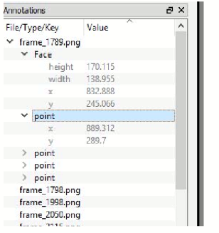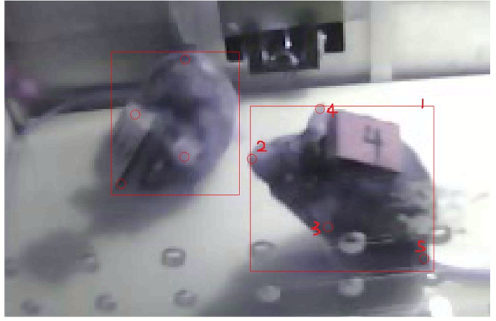

Above and to the right is an example of annotation. Example order: ​mouse1 [Face(the bounding box)-nose-Left ear-Right ear-Tailbase] -> mouse2 [Face-nose-Left ear-Right ear-Tailbase]​. I try to label the tips of the ears and the middle of the tailbase.

* You need to be consistent with your bounding box e.g. if you are including the tail always do so.

7. Save (just click save) the json file before exiting the program.

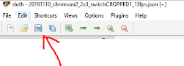

8. Move the ​/im​ folder (images annotated together with the json file) to a new folder in ​./The Annotation Tool/annotated images​.

9. Start a new session by creating a new im folder in /json and move the images you want to annotate into the im folder.